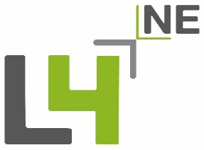
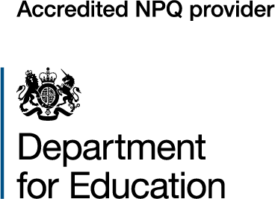

NPQs Participant Guide
‘The Essentials’

Delivery and improvement plans 2019 /2020

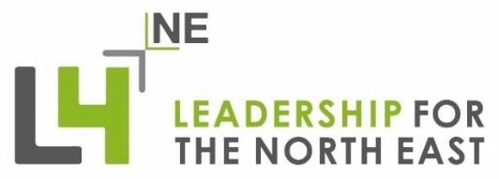
- Overview
The DfE accredits a small number of providers (Including L4NE) to design, deliver and assess the National Professional Qualifications (NPQs).
The NPQs comprise the:
*National Professional Qualification for Middle Leadership (NPQML) for those that are, or are aspiring to be, a middle leader with responsibility for leading a team.
*National Professional Qualification for Senior Leadership (NPQSL) for leaders that are, or are aspiring to be, a senior leader with cross-school responsibilities.
**National Professional Qualification for Headship (NPQH) for leaders that are, or are aspiring to be, a headteacher or head of school with responsibility for leading a school.
*There is no formal assessment process before participants are accepted onto ML and SL programmes. However, those who wish to take NPQSL will need to be able to demonstrate that they have some cross-school and whole-school responsibilities in addition to significant operational and management tasks that enable a school or academy to run smoothly on a day-to-day basis. Participants for NPQML might include staff who have recently taken on a middle leadership role and also those who are more established or experienced in their middle leadership role.
**There is a Gateway Assessment process for NPQH - see the L4NE Website to download the NPQH application form

- Final Assessment tasks and submission ‘windows’
For each NPQ, there are defined tasks setting out how a participant will be assessed. These describe the project(s) a participant will need to complete, and the supporting evidence they will need to include as part of the assessment stage. L4NE Assessment Workshops will support this process during the 11/12 months of the programmes.
For:
• NPQML, participants must lead a school improvement project within their team, lasting at least 2 terms, aimed at improving pupil progress (part A) and team capability (part B)
• NPQSL, participants must lead a school improvement project within their team, lasting at least 2 terms, aimed at reducing variation in pupil progress and attainment (part A) and improving the efficiency and effectiveness of teaching (part B)
• NPQH, participants must lead a school change programme, lasting at least 2 terms, to improve pupil progress and attainment (task 1) and design an action plan to meet their placement school’s resourcing and capability needs (task 2)
All participants are expected to be ready for final assessment within 18 months of starting the programme and so participants should ensure they are well prepared for submission within this timescale. We provide ‘windows’ for submission to final assessment at 12, 15 and 17 months from the start of the programme. Where a participant ‘books’ a final submission and fails to submit within that window there will be an administration fee of £50 – similarly there will be an administration fee of £50 where a participant changes to another window with less than 4 weeks to go. Participants will need to inform Anna Herdman of their selected submission ‘window’. Please keep us informed!
To submit for final assessment participants will need to have attended/participated in at least 75% of the course: face-to-face days and on-line learning. If any participant does not meet the standard with their first submission (costs included) they can resubmit – there will be an additional cost of around £110 depending on the level of qualification. We would endeavour to give close support to any participant in this situation.
Once an assessment submission has been made you can generally expect to receive results and feedback within 12 weeks (This period includes a national moderation process conducted by Tribal - DfE’s Quality Assurance Agent). If successful in final assessment you will be able to download your NPQ certificate.
L4NE take malpractice very seriously – please see our related policies on the L4NE website.
For more information on final assessment please see the appropriate Final Assessment Handbook provided by NPQonline – available on the L4NE information portal.

- Your L4NE Leadership Programme
Design and delivery of our NPQs offer rigorous programmes of study, exploring the role of leadership through six themes which set out what a leader should know or be able to do and seven leadership behaviours.
Full details of the DfE content framework can be found here:
National Professional Qualification (NPQ) Content and Assessment Framework
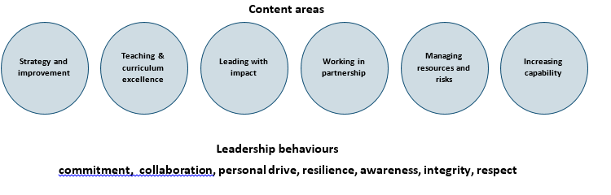
L4NE deliver ‘blended - content-based’ programmes. This approach takes into account the core principles of effective adult learning to ensure participants maximise their potential and develop current practice and effectiveness in their role as school leaders. The programme will support participants to move significantly forward in their thinking and become even more effective in leading school improvement.
To ensure our participants receive the best possible experience and highest quality professional learning, a variety of approaches are used to deliver content:
• face-to-face delivery sessions within a variety of different school venues (typically hours are 9.30 a.m. to 4.00 p.m.)
• online learning based around two content themes -provided by NPQonline – (approx. 8 /10 hours in total over 2 weeks)
• work based learning (time considerations will vary significantly - depending on the programme)
• peer learning through face-to-face and ‘online’ forums
• the L4NE NPQ Autumn Conference e.g. in November ‘19 ‘Evidenced Based Leadership’ with Professor Robert Coe
• 360 diagnostic – self assessment & ‘emotional intelligence’
• ongoing technical and ‘subject expert’ support for participants throughout the leadership programmes
• submission to final assessment – twilight assessment workshops
• NPQonline provide a trusted service on behalf of L4NE to mark and moderate our NPQ assessments
• NPQH participants have other aspects and activities within their programme (see NPQH course outline)
Costs for all of the above is included within the price of our programmes
L4NE Costs for 2019/2020 NPQML £770 NPQSL £870 NPQH £1890
Please note schools will be invoiced following the first face to face day.
A fundamental principle of the NPQ programmes is that of self-directed learning and that highly effective leaders continue to learn. Participants will be encouraged throughout the programme to take responsibility for their own learning and to use a range of tools, reading, activities and workplace experiences to support them to become more confident, optimistic and informed leaders.
Our online portal provides information and a resources library which is only accessible to our participants through user-name and password – here participants will also be able to find up to date information/documentation for final assessment.

- Our facilitators
Our team of facilitators are highly successful serving leaders – they are grounded in day to day practice to enhance participants’ learning experience. They are wholly credible - working in North East/North West schools.
We use facilitators from all phases and sizes of school so all participants recruited onto NPQH, NPQSL or NPQML programmes can feel confident that they are in ‘safe-hands’!

- Deferral and withdrawal
We recognise that exceptional circumstances do occur which may impact on a participant’s attendance and capability and/or school issues adversely affect capacity to complete the programme and/or submit for final assessment within the eighteen-month time frame. At L4NE we seek to provide a very personal and bespoke customer service and we appreciate that school leaders can be affected by significant changes in personal circumstances. Participants facing real difficulties (extenuating circumstances) can apply for a final assessment deferral/extension. L4NE will respond to any request/application for deferral quickly (within 5 working days) and on its merits.
The following situations may be deemed as extenuating circumstances:
Illness / medical condition ☐ Personal/emotional circumstance ☐ Parental leave ☐ Prolonged jury service ☐ Project change ☐ Significant change in employment status ☐ Changes within school ☐ Sponsor/headteacher ☐ Other ☐
(Access to a deferral form and our full withdrawal and deferral policy is on the L4NE website)

- DfE NPQ Participant Survey / feedback / complaints
Prior to submitting the final assessment script participants will be asked to complete an end of programme on-line NPQ participant survey. This is a requirement set by the DfE and Tribal the NPQ Quality Assurance Agent. As your chosen provider L4NE welcomes and values your feedback and we ask participants to complete this survey by the required deadline. It importantly allows L4NE to gauge what is going well and what we need to do to improve our provision.
Beyond this survey, L4NE welcomes feedback at any stage during the NPQ programme and on any aspects of our provision and assessment systems (Also see the customer care section in our Quality Assurance and Expectations document).
If you are dissatisfied with aspects of our programme please contact us directly. If you require further information regarding our policy for complaints and our appeals procedures please see the L4NE website.

- Policies and procedures
Please see the L4NE website https://www.l4ne.com/ under the heading ‘Further Information’ for access to our policies on data protection - including cyber essentials, malpractice and our complaints procedures.

- Who to contact:

For any questions or queries please contact:
Programme management / administration
Anna Herdman aherdman@stbedes.durham.sch.uk
01207 520424
L4NE Programme Leader
Roger Purdy – St Bede’s, Lanchester, rpurdy@stbedes.durham.sch.uk
01207 520424

Please see the L4NE ‘Excellence and Expectations’ document on the L4NE website for more information about our quality assurance processes.
(this document was reviewed in December 2019)

