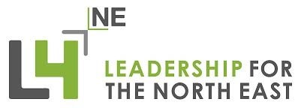

NPQ Withdrawal/Deferral
Request Form 2019 2020
IMPORTANT INFORMATION
Please complete all appropriate sections and return to:
aherdman@stbedes.durham.sch.uk
An incomplete request form will cause delays in your application and may result in your request being rejected
Please note, we will make each decision on an individual basis
A decision on your request will be made within 5 working days

Section 1: Participant details
- Surname:

- First name:

- Programme: NPQML ☐ NPQSL ☐ NPQH ☐

- Cohort start date – this should relate to the date of your first session:

- Email:

- Tel:

- Sponsor/Line Manager or Headteacher name:

Email address:

- The date you are required to submit for final assessment:

Section 2:
Do you wish to either withdrawal or defer?

Withdrawal ☐
If withdrawal, please provide your explanation in section 4 and section 5.

Please note if you are a Scholarship Funded Participant your school may be asked to reimburse any funds claimed back by the DfE.

1
L4NE Withdrawal / Deferral Procedures 2019 2020

Deferral ☐
If deferring, please complete sections 3, 4 and section 5 and advise the period of time you are requesting to defer

Section 3: Summary of extenuating circumstance(s) Nature of extenuating circumstances:
Associated with Coronavirus ☐
llness / medical condition ☐Personal/emotional circumstance ☐ Parental leave ☐
Prolonged jury service ☐ Project change ☐ Significant change in employment status ☐ Changes within school ☐ Sponsor/headteacher ☐ Other ☐

Section 4: Explanation of situation
Please provide a short description of your circumstance(s). Please be specific about how your circumstance(s) affect(s) your ability to submit your project for final assessment and include any relevant dates.

If the request is for deferral – how long do you wish to defer?

Section 5: Declaration

Participant Name / Signature:

Date:

By signing this form you declare that the information and supporting documentation is true and accurate.

